- Introduction
  - Problem Definition
Web applications are applications that can be accessed over the Internet by using any compliant Web browser that runs on any operating system and architecture. They have become ubiquitous due to the convenience, flexibility, availability, and interoperability that they provide. Unfortunately, Web applications are also vulnerable to a variety of new security threats. SQL Injection Attacks (SQLIAs) are one of the most significant of such threats. SQLIAs have become increasingly frequent and pose very serious security risks because they can give attackers unrestricted access to the databases that underlie Web applications. When the Web application builds a query by using these strings and submits the query to its underlying database, the attacker’s embedded commands are executed by the database and the attack succeeds. The results of these attacks are often disastrous and can range from leaking of sensitive data .There are alternative techniques to address SQLIAs, but many of these solutions have limitations that affect their effectiveness and practicality.
In our approach we are going to propose a system for detection of SQLIA, it works on identification of “trusted” strings and allowing only trusted strings to be used to create the semantically relevant parts of a SQL Query.
1.2 SQL Injections
Structured Query Language ('SQL') is a textual language used to interact with relational databases. There are many varieties of SQL; most dialects that are in common use at the moment are loosely based around SQL-92, the most recent ANSI standard. The typical unit of execution of SQL is the 'query', which is a collection of statements that typically return a single 'result set'. SQL statements can modify the structure of databases (using Data Definition Language statements, or 'DDL') and manipulate the contents of databases (using Data Manipulation Language statements, or 'DML').

SQL Injection occurs when an attacker is able to insert a series of SQL statements into a 'query' by manipulating data input into an application.
A typical SQL statement looks like this:

select id, forename, surname from authors

This statement will retrieve the 'id', 'forename' and 'surname' columns from the 'authors' table, returning all rows in the table. The 'result set' could be restricted to a specific 'author' like this:
select id, forename, surname from authors where forename = 'john' and surname = 'smith'
An important point to note here is that the string literals 'john' and 'smith' are delimited with single quotes
SQL injection attacks (SQLIAs) are one of the major security threats for Web applications . Successful SQLIAs can give attackers access to and even control of the databases that underly Web applications, which may contain sensitive or confidential information. Despite the potential severity of SQLIAs, many Web applications remain vulnerable to such attacks. In general, SQL injection vulnerabilities are caused by inadequate input validation within an application. Attackers take advantage of these vulnerabilities by submitting input strings that contain specially-encoded database commands to the application. When the application builds a query using these strings and submits the query to its underlying database

Web applications interface with databases that contain information such as customer names, preferences, credit card numbers, purchase orders, and so on. Web applications build SQL queries to access these databases based, in part, on user-provided input. The intent is that Web applications will limit the kinds of queries that can be generated to a safe subset of all possible queries, regardless of what input users provide. However, inadequate input validation can enable attackers to gain complete access to such databases. One way in which this happens is that attackers can submit input strings that contain specially encoded database commands. When the Web application builds a query by using these strings and submits the query to its underlying database, the attacker’s embedded commands are executed by the database and the attack succeeds. The results of these attacks are often disastrous and can range from leaking of sensitive data to the destruction of database contents

  - Scope
Our approach against SQLIAs is based on dynamic tainting, which has previously been used to address security problems related to input validation. Traditional dynamic tainting approaches mark certain untrusted data as tainted, track the flow of tainted data at runtime, and prevent this data from being used in potentially harmful ways. Our approach makes several conceptual and practical improvements over traditional dynamic tainting approaches by taking advantage of the characteristics of SQLIAs and Web applications. First, unlike existing dynamic tainting techniques, our approach is based on the novel concept of positive tainting, that is, the identification and marking of trusted, instead of untrusted, data. Second, our approach performs accurate and efficient taint propagation by precisely tracking trust markings at the character level. Third, it performs syntax-aware evaluation of query strings before they are sent to the database and blocks all queries whose non-literal parts contain one or more characters without trust markings. Finally, our approach has minimal deployment requirements, which makes it both practical and portable.
- Unlike existing dynamic tainting techniques, our approach is based on the novel concept of positive tainting, that is, the identification and marking of trusted, instead of untrusted.
- Our approach performs accurate and efficient taint propagation by precisely tracking trust markings at the character level.
- It performs syntax-aware evaluation of query strings before they are sent to the database and blocks all queries whose non-literal parts.

  - User Characteristics
We have identified five potential classifications of users of our system:
- Software Designers: These are the most obvious users. They will use the system as a means of laying out the design of an as yet unimplemented system.
- Software Developers: These are the people that take the model generated by the designers and implement it in code. They may also use the system to identify the design of an existing system in order to maintain it.
- Quality Engineers: These users are usually responsible for ensuring that a design is feasible and/or reliable. They will therefore also need to be looking at the output from our system.
- System Administrator: Due to the client/server/concurrent nature of the system, someone needs to be responsible for security and maintenance of the system. This is the System Administrators role. The Administrator of the system, project or model need not be a member of the any of the other roles identified here.
- The Client: More often than not, software is designed for a client. The client may wish to see the design as laid out by the system and be able to see what exactly they are buying.
    - General User
All users can be assumed to have the following characteristics:
- Ability to read and understand English.
- Familiarity with the operation of the basic Graphical User Interface (GUI) components of the Windows NT operating system.
- Beyond the above, no further facility with computer technology can be assumed.
    - The Software Designer
The Software Designer users can be assumed to have the following characteristics:
- A thorough knowledge of object oriented design notation.
- Familiarity with common design environments. For example, the concept of selecting a tool to draw with.
- Software Developers User Characteristics.
    - the Quality Engineer

The Quality Engineer users can be assumed to have the following characteristics:
- A thorough knowledge of object oriented design notation.

- Techniques To Prevent the SQL injection
To prevent the web application three techniques by use of this technique we can find the injection data’s and send the correct query to the SQL server.
1. Positive-Tainting
2. Character-level tainting.
3. Syntax aware

2.1 Positive-Tainting:

Positive tainting differs from traditional tainting because it is based on the identification, marking, and tracking of trusted, rather than untrusted, data. This conceptual difference has significant implications for the effectiveness of our approach, in that it helps address problems caused by incompleteness in the identification of relevant data to be marked. Incompleteness, which is one of the major challenges when implementing a security technique based on dynamic tainting, has very different consequences in negative and positive tainting. In the case of negative tainting, incompleteness leads to trusting data that should not be trusted and ultimately to false negatives. Incompleteness may thus leave the application vulnerable to attacks and can be very difficult to detect, even after attacks actually occur, because they may go completely unnoticed. With positive tainting, incompleteness may lead to false positives, but it would never result in an SQLIA escaping detection.

2.2 Character level-Tainting:
User track taint information at the character level rather than at the string level. We do this because, for building SQL queries, strings are constantly broken into substrings, manipulated, and combined. By associating taint information to single characters, approach can precisely model the effect of these string operations. Another alternative would be to trace taint data at the bit level, which would allow us to account for situations where string data are manipulated as character values using bitwise operators. However, operating at the bit level would make the approach considerably more expensive and complex to implement and deploy. Most importantly, our experience with Web applications shows that working at a finer level of granularity than a character would not yield any benefit in terms of effectiveness. Strings are typically manipulated using methods provided by string library classes and we have not encountered any case of query strings that are manipulated at the bit level.
  - Syntax Aware Evaluation:
Syntax-aware evaluation of a query string immediately before the string is sent to the database to be executed. To evaluate the query string, the technique first uses a SQL parser to break the string into a sequence of tokens that correspond to SQL keywords, operators, and literals. The technique then iterates through the tokens and checks whether tokens (i.e. substrings) other than literals contain only trusted data. If all such tokens pass this check, the query is considered safe and is allowed to execute. If an attack is detected, a developer’s specified action can be invoked.
This default approach, which considers only two kinds of data (trusted and untrusted) and allows only trusted data to form SQL keywords and operators, is adequate for most Web applications.

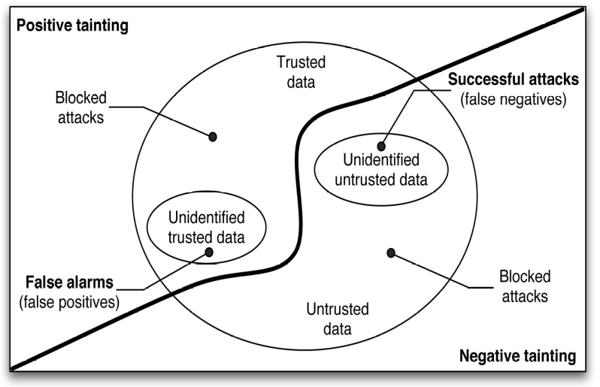
Identification of trusted and untrusted data
  - Accurate Taint Procedure

Taint propagation consists of tracking taint markings associated with the data while the data is used and manipulated at runtime. When tainting is used for security-related applications, it is especially important for the propagation to be accurate. Inaccurate propagation can undermine the effectiveness of a technique by associating incorrect markings to data, which would cause the data to be mishandled. In our approach, we provide a mechanism to accurately mark and propagate taint information by tracking taint markings at a low level of granularity and precisely accounting for the effect of functions that operate on the tainted data. Character-level tainting. We track taint information at the character level rather than at the string level. We do this because, for building SQL queries, strings are constantly broken into substrings, manipulated, and combined. By associating taint information to single characters, our approach can precisely model the effect of these string operations. Accounting for string manipulations. To accurately maintain character-level taint information, we must identify all relevant string operations and account for their effect on the taint markings (i.e., we must enforce complete mediation of all string operations). Our approach achieves this goal by taking advantage of the encapsulation offered by object-oriented languages, and in particular by Java, in which all string manipulations are performed using a small set of classes and methods. Our approach extends all such classes and methods by adding functionality to update taint markings based
on the methods’ semantics.

- System Design Models
3.1 Work Flow of the Application

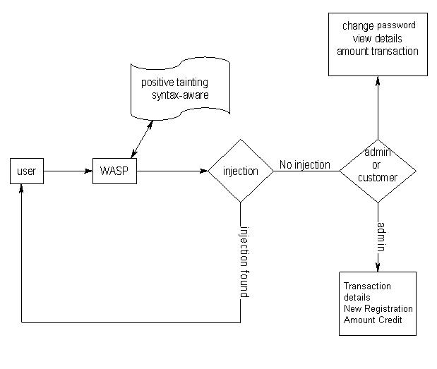

3.2 Use Case Diagram
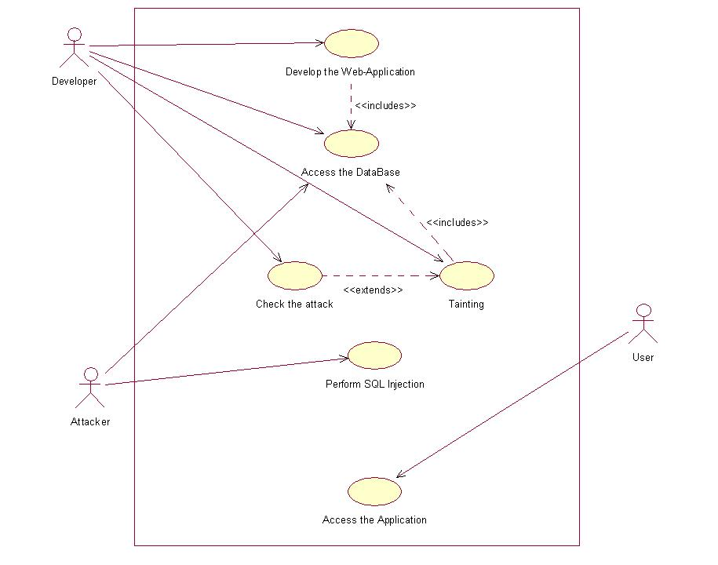

  - Class Diagram

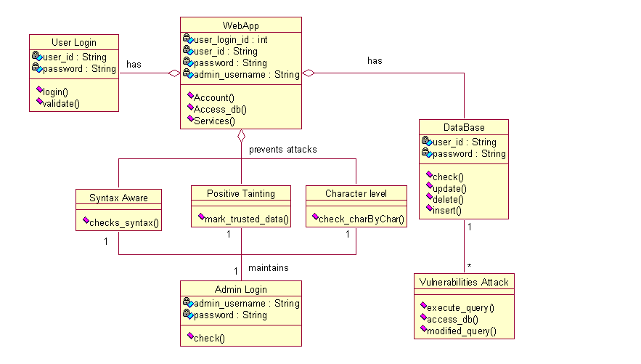

  - Sequence Diagram
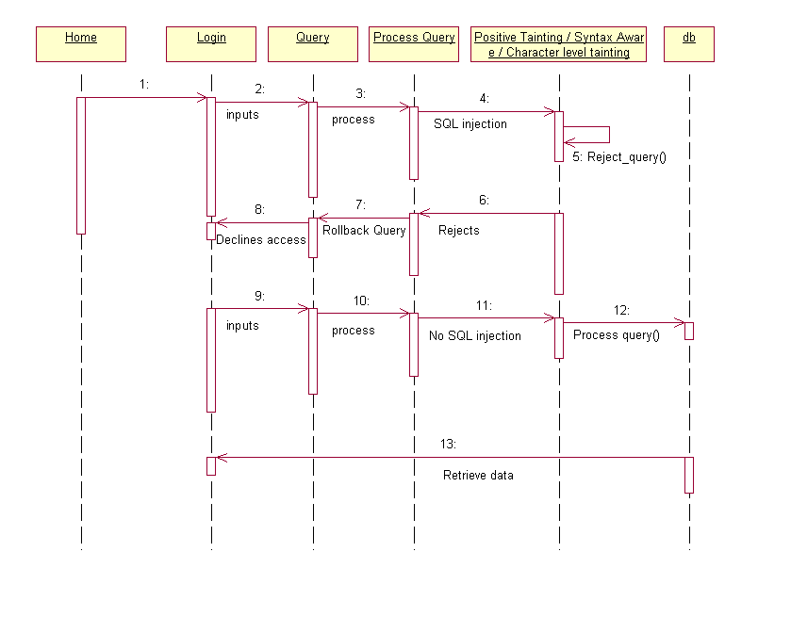

  - Activity Diagram
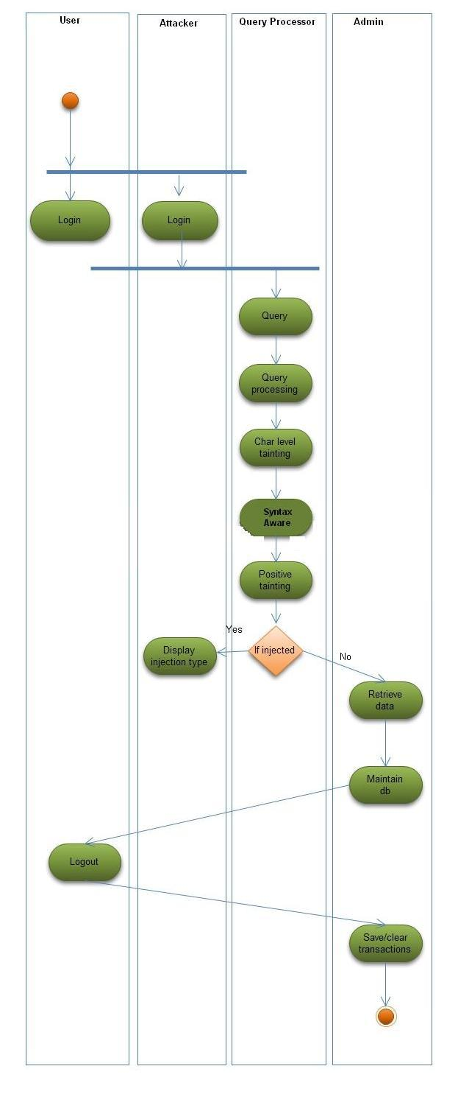
  - State Diagram
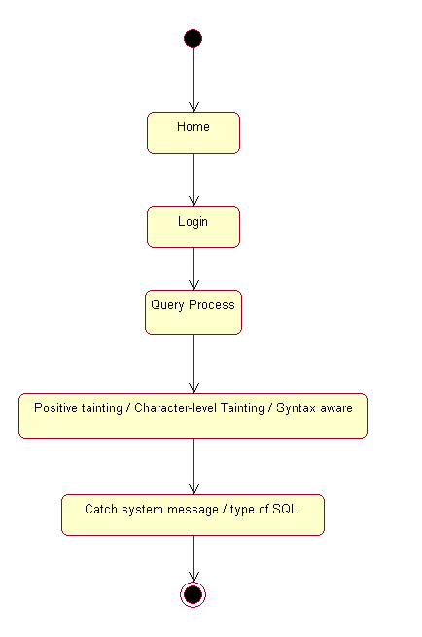

  - Component Diagram
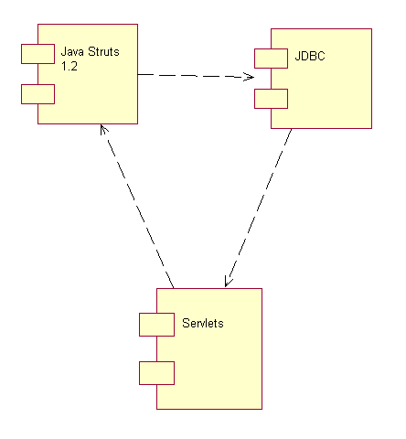

  - Package Diagram
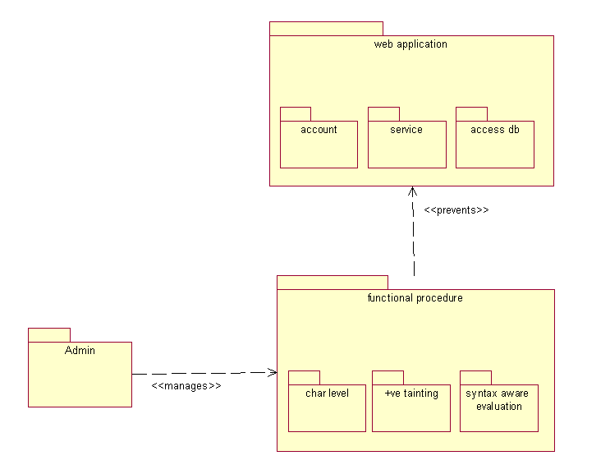

  - Collaboration Diagram
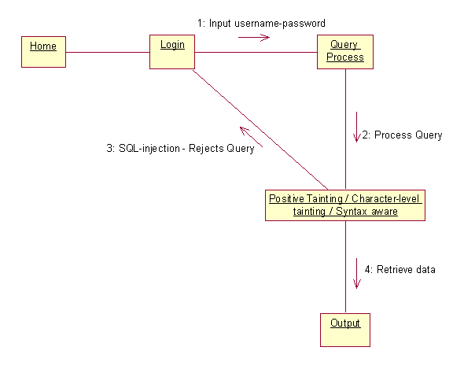

3.10 Deployment Diagram
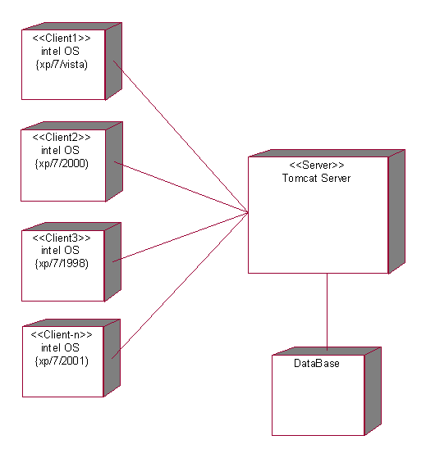

- System Architecture
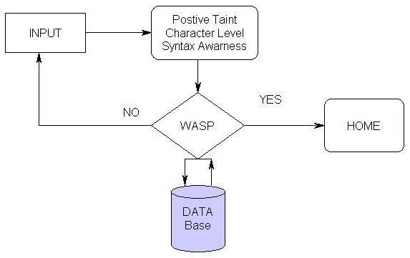

Modules
- Admin
- Customer
- Credit Card
- Loans
- Positive tainting
- Character level tainting
- Syntax Aware

1. Admin:

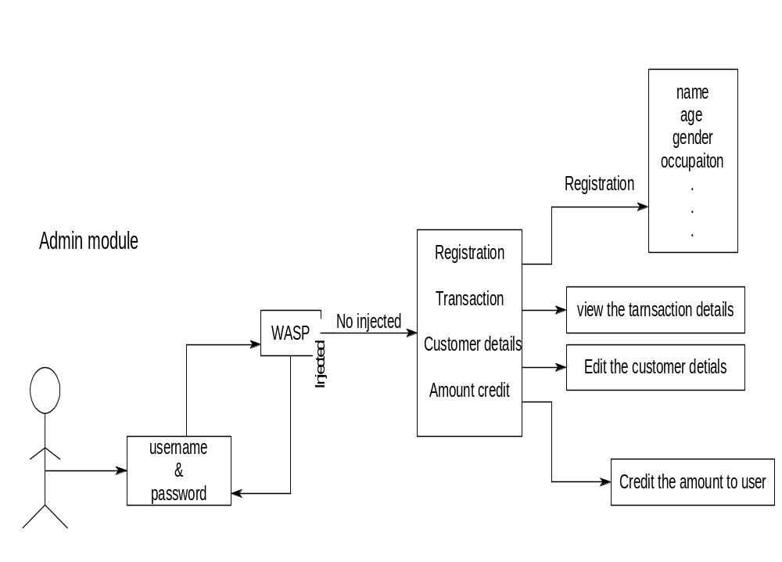
Login in:
To access our site ever person must login in that page it has account number and password. The admin must enter his account number and password that values is checked in the data base weather the give values in correct if they give value is correct means is show the next page otherwise it return to login page with error message (Invalid account number and password).
New Registration:
After the admin login successfully the first sub modules is registration module. In this module admin enter the new user details ie.name, address, occupation, type of account… account number ,pin number and amount. by the use of the account number and pin only customer login in his module .before the data insert into data base it check whether the account is available or not then it insert the data .
Transaction:
This is the second module of admin module in this admin can view only the transaction details .in that page it shows user details that’s are sender name, data and time,receiver name, account number, amount you send it.
Customer details:
This is the third module of the admin in this module in show the customer details. This module is use to edit some details of the particular customer. In this module it show all the customer details who are all in our bank when you want to delete or edit the particular customer details click his name and it show the all the details of the that customer admin go and edit the particular field which we want to edit and press the update button
Amount credit:
This is the last module of the admin. In that module admin enter the amount the his account manually .admin click the links in show the page it contain account number field and amount field so admin enter the correct account number and amount and press the enter button the amount is added in that customer account

2. Customer:
This module customer can view his details and change the password and send the amount to another account. To process this he/she must login by his account number and password. This module has two sub-modules.
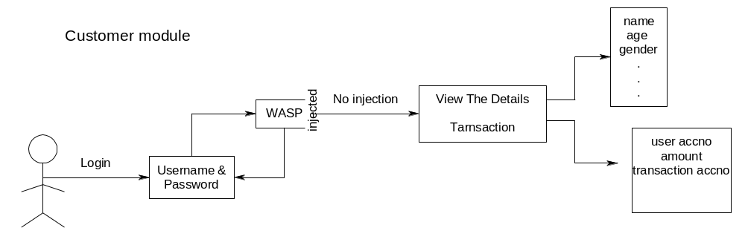
Login in:
To access our site ever person must login in that page it has account number and password. The customer must enter his account number and password that values is checked in the data base weather the give values in correct if the given value is correct means is show the next page otherwise it return to login page with error message (Invalid account number and password).
Customer details:
This is the first module of the customer in this module customer can change his password of his account because admin only create his account and pin number it was known to the admin in not safe so we want to change the pin number .the customer can have access to change it pin number only .before the value going to SQL query the WASP tool check each given data is good or not i.e. weather it injected the present query or not.
Transaction:
In this module the customer can send the amount from his account to another account, if that sending amount is available. The customer must login and move to the transaction module and type the account number and amount which he wants to send and submit the query. Before the value is send to the database, the WASP tool gets invoke and checks the given data, if it is injected i.e. SQL Query is present or not. If not, then only it will be sent to the database.
3. Credit card:
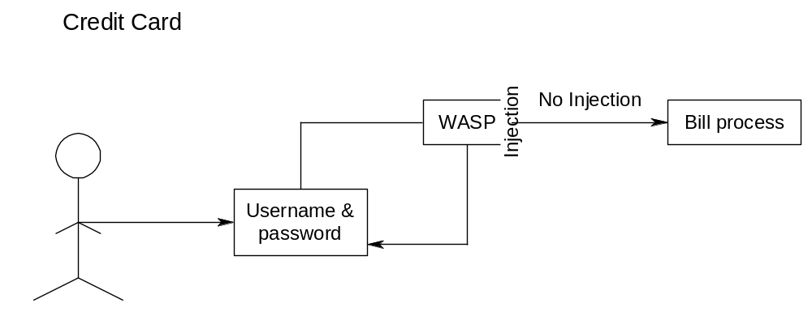Login in:
To access our site ever person must login in that page it have account number and password .the customer must enter his account number and password that values is checked in the data base weather the give values in correct.
Bill credit:
After the customer login successfully it shows the sub module in that module. The customer can pay his bills through his card in our project we set two option to pay the bill one is electric bill another bill is cell phone bill.

- Loans
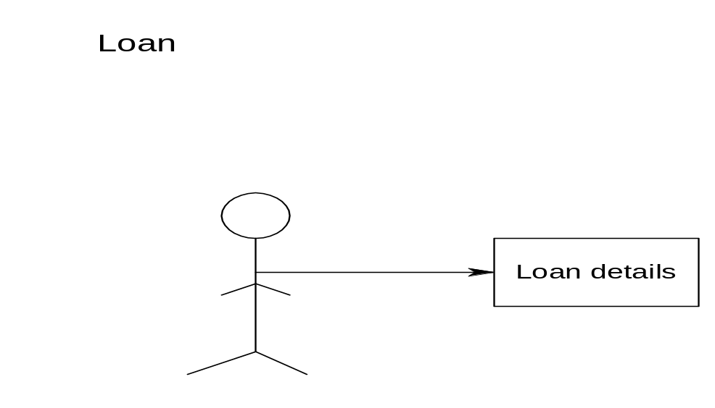
In this module viewer can see what the loans available in this bank are and get the details of the loans. This module can see anyone who accessing the application.

- Positive Tainting (Security Module)
Positive tainting differs from traditional tainting because it is based on the identification, marking, and tracking of trusted, rather than untrusted, data. This conceptual difference has significant implications for the effectiveness of our approach, in that it helps address problems caused by incompleteness in the identification of relevant data to be marked. Incompleteness, which is one of the major challenges when implementing a security technique based on dynamic tainting, has very different consequences in negative and positive tainting. In the case of negative tainting, incompleteness leads to trusting data that should not be trusted and ultimately to false negatives. Incompleteness may thus leave the application vulnerable to attacks and can be very difficult to detect, even after attacks actually occur, because they may go completely unnoticed. With positive tainting, incompleteness may lead to false positives, but it would never result in an SQLIA escaping detection.
Input: Input any String as a query.

Algorithm:
- Create Class PositiveTaint.
- Define Method ClassCode.
- When the input String contains ASCII value 27 to 122 i.e. it contains upper, lower character and some symbol then read contains of foo.txt (foo.txt includes the marked data) .it is nothing but tracking and marking of data.
- Then split the string and check account no. and password and tell the administrator SQL injection found or not.

Output: If inserted Query is correct then query processes and give user access to database else deny access and display injection type.

- White-list policy - Identification, marking and tracking of trusted, rather than untrusted, data.

- Character-level Tainting (Security Module)
User track taint information at the character level rather than at the string level. We do this because, for building SQL queries, strings are constantly broken into substrings, manipulated, and combined. By associating taint information to single characters, approach can precisely model the effect of these string operations. Another alternative would be to trace taint data at the bit level, which would allow us to account for situations where string data are manipulated as character values using bitwise operators. However, operating at the bit level would make the approach considerably more expensive and complex to implement and deploy. Most importantly, our experience with Web applications shows that working at a finer level of granularity than a character would not yield any benefit in terms of effectiveness. Strings are typically manipulated using methods provided by string library classes and we have not encountered any case of query strings that are manipulated at the bit level.

Input: Input any String as a query.

Algorithm:
- Create Class CharacterLevel.
- Define Method calculate.
- Input string.
- Check in String presence of symbol ‘-‘ if this found check next symbol is’-‘ if this found then give injection type and exit.
- check string presence of 'O' or 'o' if found check if next character is ‘r’ or’R’. if found then tell injection type and exit.
- Check in String prensence of ’;’ if found then give failure result and injection type and exit.

Output: If inserted Query is correct then query processes and gives user access to database else deny access and display injection type.

- Syntax Aware (Security Module)
Syntax-aware evaluation of a query string immediately before the string is sent to the database to be executed. To evaluate the query string, the technique first uses a SQL parser to break the string into a sequence of tokens that correspond to SQL keywords, operators, and literals. The technique then iterates through the tokens and checks whether tokens (i.e. substrings) other than literals contain only trusted data. If all such tokens pass this check, the query is considered safe and is allowed to execute. If an attack is detected, a developer’s specified action can be invoked.

This default approach, which considers only two kinds of data (trusted and untrusted) and allows only trusted data to form SQL keywords and operators, is adequate for most Web applications.

Input: Input any String as a query.
Algorithm:
- Create Class SyntaxAware.
- Define Method Function.
- Input string and set syntax.
- If inserted query is equal to database Query then split the query into substring and check the syntax and then display final query .

Output: After checking the syntax of the query then insert all the details in the database.

- Screenshots of the Web Application
Admin Login
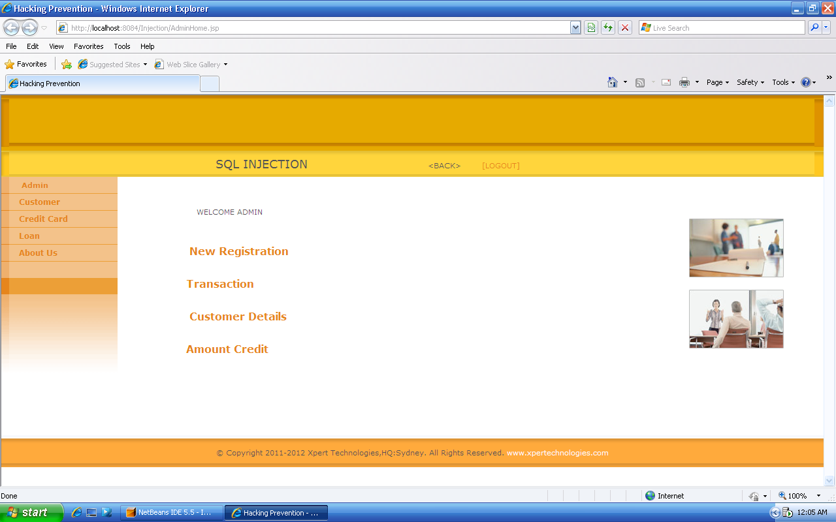
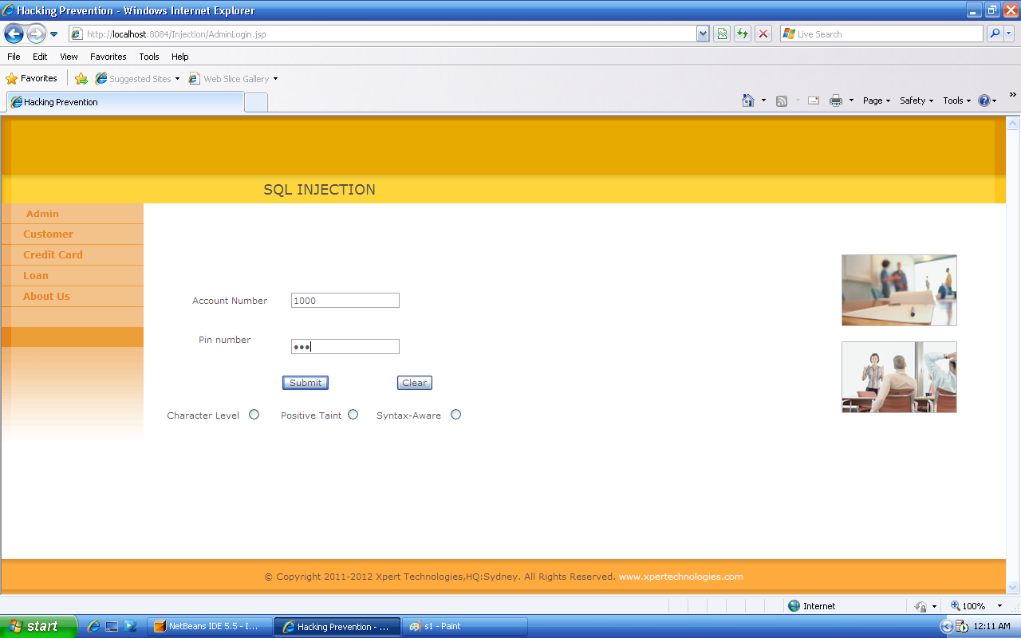

Customer Details
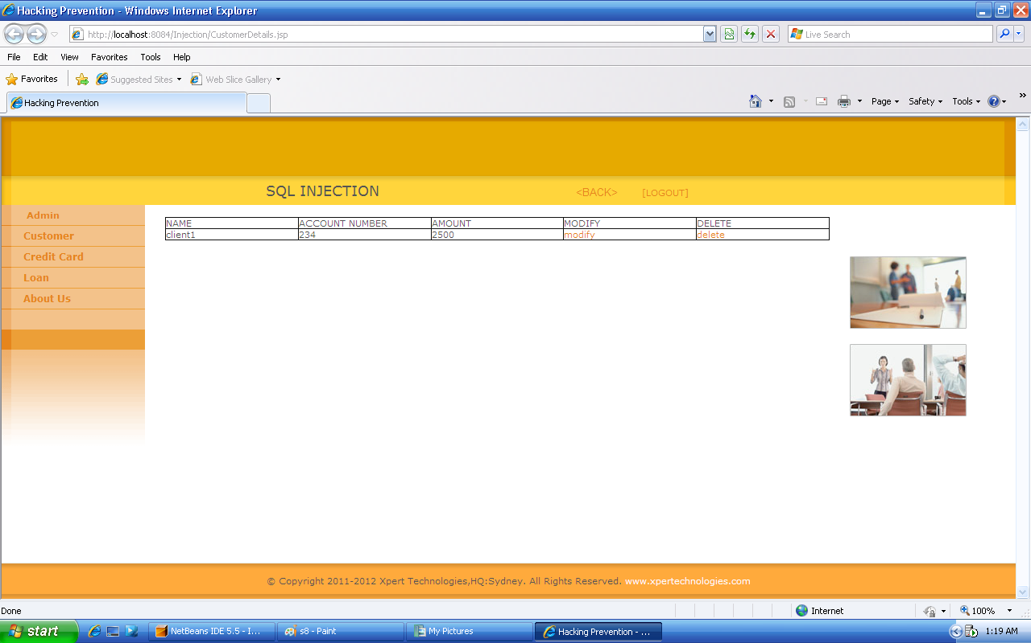

New Registration
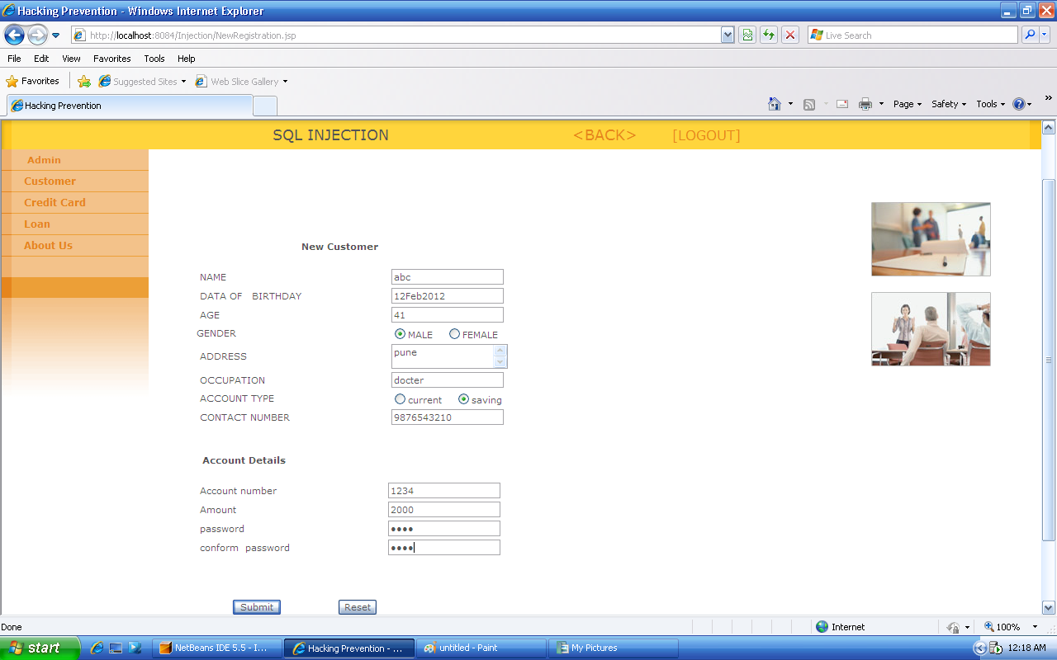

Character-level tainting
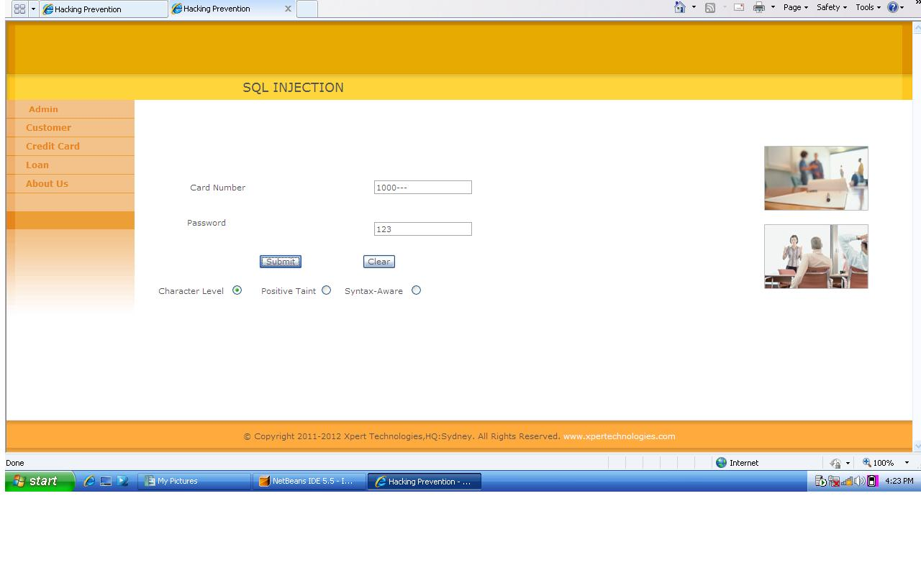
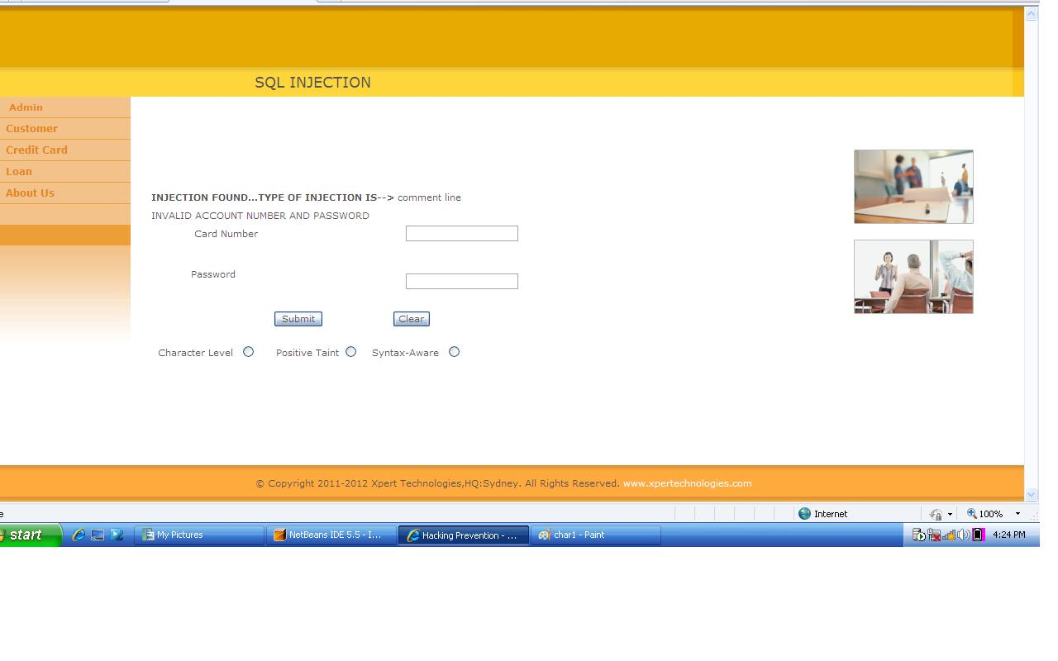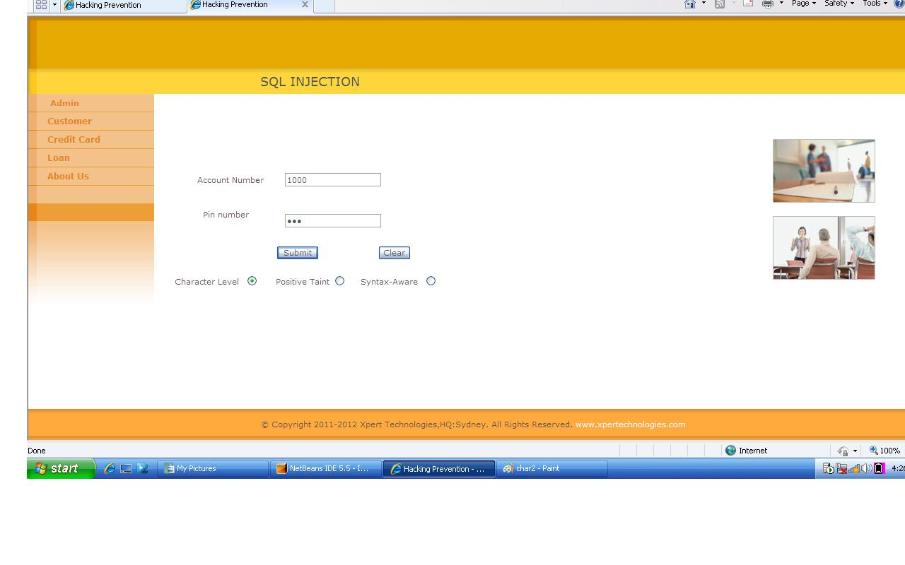

Syntax-Aware
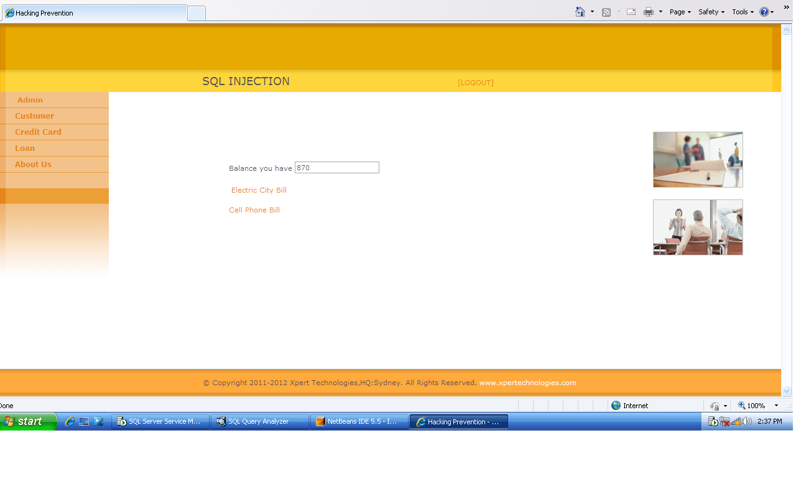

Positive-tainting
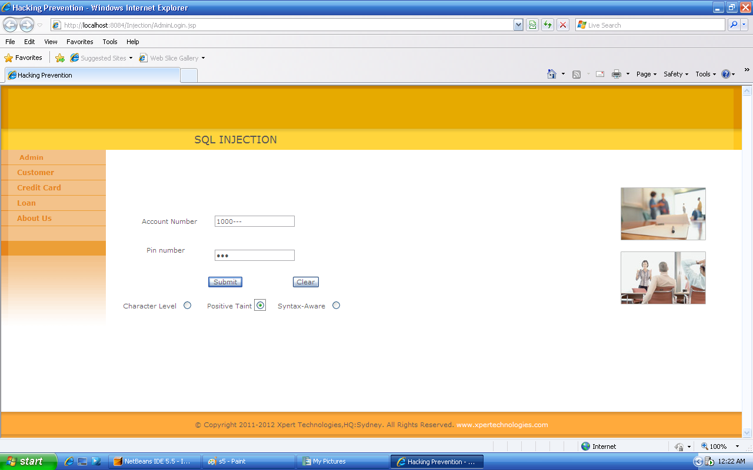

- Conclusion
With this approach based on positive tainting, we can eliminate the problem of false negatives that may result from the incomplete identification of all untrusted data sources. As this technique explicitly identifies trusted, rather than untrusted data in a program (unlike previous approaches based on dynamic tainting).
This approach also provides practical advantages over the many existing techniques such as:
- It is defined at the application level,
- requires no modification of the runtime system,
- does not require customized and complex running environments,
- and imposes a low execution overhead.

- Advantages and disadvantages.
Advantages:
- Our approach is highly automated & in most cases require minimal or no developer intervention
- It does not require additional infrastructure and can be automatically deployed.
- Our approach makes several conceptual and practical improvements that take advantage of the specific characteristics of SQLIA’s.
- We use Positive tainting which leads to increased automation.
- Our approach is the use of flexible syntax aware evaluation.

Disadvantages:
- We need to reconfigure project as per client request.

- References
- WASP: Protecting Web Applications Using Positive Tainting and Syntax- Aware Evaluation", William G.J. Halfond, Alessandro Orso, Panagiots Manolios IEEE Transaction of Software Engineering Vol 34, Nol, January/February 2008. The Essence of Command Injection Attacks in Web Applications
- Syntax Aware Evaluation to Counter SQL- Injection Attacks, Alex Orso with William Halfond, Georgia Institute if Technology
- Countering SQL Injection Attacks A proof of Concept , Benjamin Hall
- SQL Injection Analysis, Detection and Prevention, Jagdish Halde, San Jose University
- Struts.apache.org
- SQL Injection Attacks and Defense, Justin Clarke
- Microsoft SQL Server book online

